LEEA DIPLOMA HUNTINGDON TRAINING CENTRE BOOKING FORM

Please note that your joining instructions will only be issued once we have received full payment for your course.

Any spaces held or booked whilst awaiting payment are subject to our cancellation fees.

Students Details

Given Name: Click or tap here to enter text. Family Name: Click or tap here to enter text.

Date of Birth: Click or tap here to enter text. LEEA Student ID (if known): Click or tap here to enter text.

Company Details

Company Name (and Branch if applicable): Click or tap here to enter text.

Address: Click or tap here to enter text.

Training Contact:

Training Contact Phone Number: Click or tap here to enter text.

Training Contact Email address: Click or tap here to enter text.

Please select the course below including the preferred date and return with a recent digital photo of the student which is required for verification following their assessment

Subject (member price/ITS price excl. VAT) | Link to dates and availability | Insert an ‘X’ as Required
LEEA Foundation Certificate @ £435 / £870 | FOU
Lifting Accessories Course Diploma @ £765 / £1530 | LAC
Powered Lifting Machines Diploma @ £765 / £1530 | PLM
Manual Lifting Machines Diploma @ £765 / £1530 | MLM
Supporting Structures Diploma @ £765 / £1530 | SUP
Bridge and Gantry Cranes Diploma @ £765 / £1530 | BGC
Offshore Container Diploma @ £765 / £1530 | OSC
Preferred course start date: Click or tap here to enter text. Alternative course start date: Click or tap here to enter text.

Purchase order number: Click or tap here to enter text.

Name of person placing order: Click or tap here to enter text.

Our payment terms can be found in our terms and conditions and if you wish to pay via credit card there is a section for that later in the form.

Employer’s Declaration (TO BE SIGNED BY EMPLOYER ONLY)
I hereby certify that this candidate is eligible to sit the course (s).

Signed
Date Click or tap here to enter text.
Name Click or tap here to enter text.
Position Click or tap here to enter text.

Employers of candidates with additional learning needs, e.g. Dyslexia, should make LEEA aware at the time of completing this form by providing a brief explanation of their difficulty below.
Click or tap here to enter text.
Individual Trainee Declaration (TO BE SIGNED BY REGISTERED INDIVIDUAL [ITS] TRAINEES ONLY)
I hereby certify that I am registered under the Individual Trainee Scheme and eligible to sit the course (s).

Signed

Date Click or tap here to enter text.
Name Click or tap here to enter text.
*Important changes*

As part of the new Academy 2.0 Diploma courses, LEEA assessments will no longer be paper based. Students will be given access to their assessment during their attendance on the course. All LEEA Assessments are CLOSED BOOK.

This must be completed on the new ‘LEEA Academy’ App, and details on how to download the application can be found on the following link, and the LEEA trainer will also show students how to do this:

https://leeaint.com/presentation/welcome-to-leea-academy-2-0.

The joining instructions for this course booking will include all of the key information and rules for the new assessment.

Assessment Resit Fees
For re-sits of Assessments, where students did not achieve the required “pass” mark on the first attempt the cost is:
Employees of LEEA Member Companies: £90 (incl. VAT) £75 (excl. VAT)
Individual Trainees: £120 (All incl. VAT to comply with UK law)

Results
All assessments are individually reviewed and verified by LEEA, and we aim to release your results within 4 weeks from the date of your assessment. They will be sent as soon as they are available.
If you work for a LEEA Member company, your results will be sent to the nominated LEEA contact or training contact at your company. If you are an Individual Trainee, we will send the results to you directly.

IMPORTANT INFORMATION REGARDING THE COURSES

- All diploma courses (excluding BGC & OSC which run Monday to Thursday 09:00 – 16:30) will commence at 09:00 and finish at 16:00 (Monday to Thursday) and 09:00 to 15:00pm at the latest (Friday).

- Our LEEA Foundation Certificate is delivered across 3 days, and will run between 09:00 – 16:00, if the course finishes on a Friday it will run 09:00 – 15:00 on the last day. The timings throughout the week may change depending on group progress but this will be communicated by the trainer.

- Whenever possible we will endeavor to provide training on the preferred dates selected on the booking form. However, places will be allocated on a first-come basis. Please therefore indicate any acceptable alternative dates.

- Lunch: students are asked to bring their own lunch as this is no longer provided. A free of charge drinks vending machine is provided for use throughout the day together with filtered and chilled freshwater towers. There is a range of local food outlets available within a 5-minute drive of the training centre.

- The Diploma training courses include a mixture of classroom and workshop sessions. Workshop sessions will involve handling equipment. Delegates should therefore be cleanly dressed and bring suitable overall and safety footwear for the practical sessions. Hand tools will be provided, and it will be the responsibility of the delegate to ensure that all tools and equipment are returned to their respective location at the end of the practical sessions.

- Students on face to face training courses have 12 months from the start date on the course to successfully complete their final assessment. They will not be eligible for resit assessments following the 12 months.

How to find us

Huntingdon is in Cambridgeshire, approximately 60 miles due North of central London. It is easily accessible by major road and rail networks and within a reasonable distance of London’s international airports.

Due to recent road upgrades your sat nav may try and direct you the previous way to our training centre. We recommend leaving the A14 or A1 when you see signs for Huntingdon Racecourse and your sat nav should then pick up the usual route.
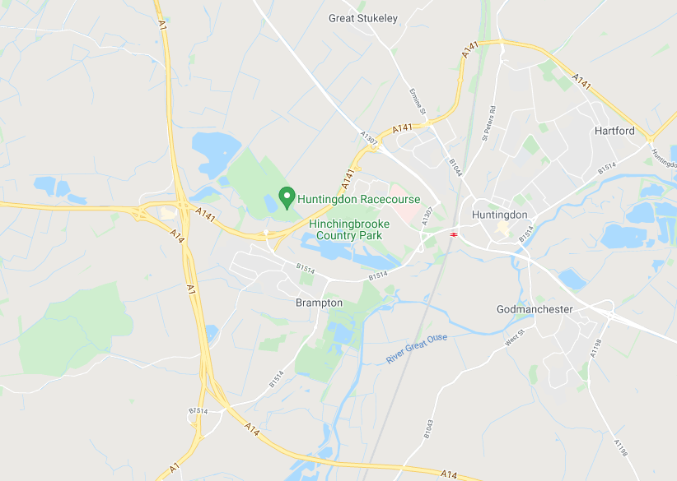



By rail - The nearest station is at Huntingdon and is on the main line North from London’s Kings Cross terminus. Taxis are available at the station.

Credit/Debit card payment:
Please complete the details below. Card type (please indicate):
MasterCard, Visa Credit, Visa Electron, Maestro, Solo, JCB, American Express, Visa Debit
Card number: Click or tap here to enter text.
Card expiry date: Click or tap here to enter text.
Security code (last 3 digits in signature box): Click or tap here to enter text.
Issue number or start date (Maestro/Solo only): Click or tap here to enter text.
Card holder’s name (as on the card): Click or tap here to enter text.

Card holder’s Signature:
Alternatively, we can issue you with a secure payment link or take payment via the phone on +44 1480 432801.

Terms and Conditions

ELIGIBILITY FOR TRAINING
- Students must be at least 16 years of age
- Students must be employed by a LEEA Member or registered with LEEA as an Individual Trainee
- Students must have passed either LEEA Foundation or the previous Part 1 Entry course to attend a Diploma course

Please note that LEEA members must only nominate their own employees for any LEEA training - if LEEA discovers that non-employees are in attendance, they will not be permitted to continue with the training course and certificates will not be issued.

ADDITIONAL LEARNING NEEDS
LEEA must be informed at the time of booking if a trainee has additional needs. Depending on what assistance and accessibility arrangements are requested, we may need to see evidence of the trainees’ additional needs. Further information about this is available on request.

PAYMENT TERMS
Payment is required in full ahead of the course start date and joining instructions will not be issued until payment is received.

Please note that any courses booked within 35 days of the course start date must be paid for at the time of booking, courses outside of this period can be invoiced but payment is required on receipt of the invoice or within our strict 30-day payment terms.

If you have made a booking pending payment, the below cancellation terms will still apply to this booking.

No member shall re-sell places on LEEA training courses to other companies or individuals.

All payments should be made in Pounds Sterling net of all currency charges.

CANCELLATION – COURSE CANCELLED BY LEEA
LEEA reserves the right to postpone or cancel a course if the number of trainees or operational demands mean that it is not viable to run the course.

Whilst very rare, if a course is cancelled due to LEEA staff illness, all fees paid by the member will be refunded in full. LEEA does not accept responsibility for costs incurred by members/ITS for loss of earnings or subsistence. Delegates are therefore strongly advised to book accommodation that may be changed or refunded due to such an unlikely eventuality. LEEA will not be responsible for lost deposits or cancellation charges.

CANCELLATION – ATTENDANCE CANCELLED BY MEMBER/ITS
If you cancel the booking or fail to show for the course, refunds will not be given. If the invoice has not been paid, or the booking is cancelled within the below policies we will invoice for the appropriate cancellation fee

Credit notes or transfers to alternative courses are available in this event, aligned to the cancellation periods stated below.

Cancellation within 7 working days of the commencement of the course = 50% of the course fee
Cancellation within 2 working days of the commencement of the course = 100% of the course fee

SUBSTITUTIONS
If a delegate becomes unavailable before the commencement of the course, a substitute may be nominated. Substitution once the course has commenced is not accepted

ENTRY FOBS
Electronic entry fobs to our Huntingdon Training Centre are issued to all students on arrival, and should be returned to the
Training Specialist at the end of each day. An administrative charge of £25 is payable if a fob is lost, not returned or damaged

CERTIFICATION
Diploma certificates will not be issued unless the LEEA Foundation Certificate assessment has been passed. All results, certificates, and Team Cards (where applicable) will be sent to the company training contact

FEEDBACK
LEEA is unable to release any assessment papers or send any extracts of information from them to companies or Individual Trainees. In the rare event that you wish to challenge your assessment result, your LEEA contact must email assessments@leeaint.com with the necessary details. Emails sent from candidates (other than Individual Trainees) will not be responded to. Your complaint/appeal will be dealt with by our team who will in turn respond to your LEEA contact with our findings. In all cases, the decision of the Deputy CEO (Chief Examiner) will be final.

Please note: any cases of plagiarism or cheating will be dealt with in accordance with our Assessment Policy (details available on request) and can result in individuals being prevented from taking a LEEA assessment for significant periods of time.

FORCE MAJURE
Force Majeure - neither LEEA or the member/individual trainee shall be liable to the other for any failure to perform any part of the agreement which is due to an event beyond the control of either party, including but not limited to terrorism, war, Political insurgence, strike, riot, civil unrest, act of civil or military authority, uprising, earthquake, flood or any other natural or man-made eventuality which may cause the termination of the event.

